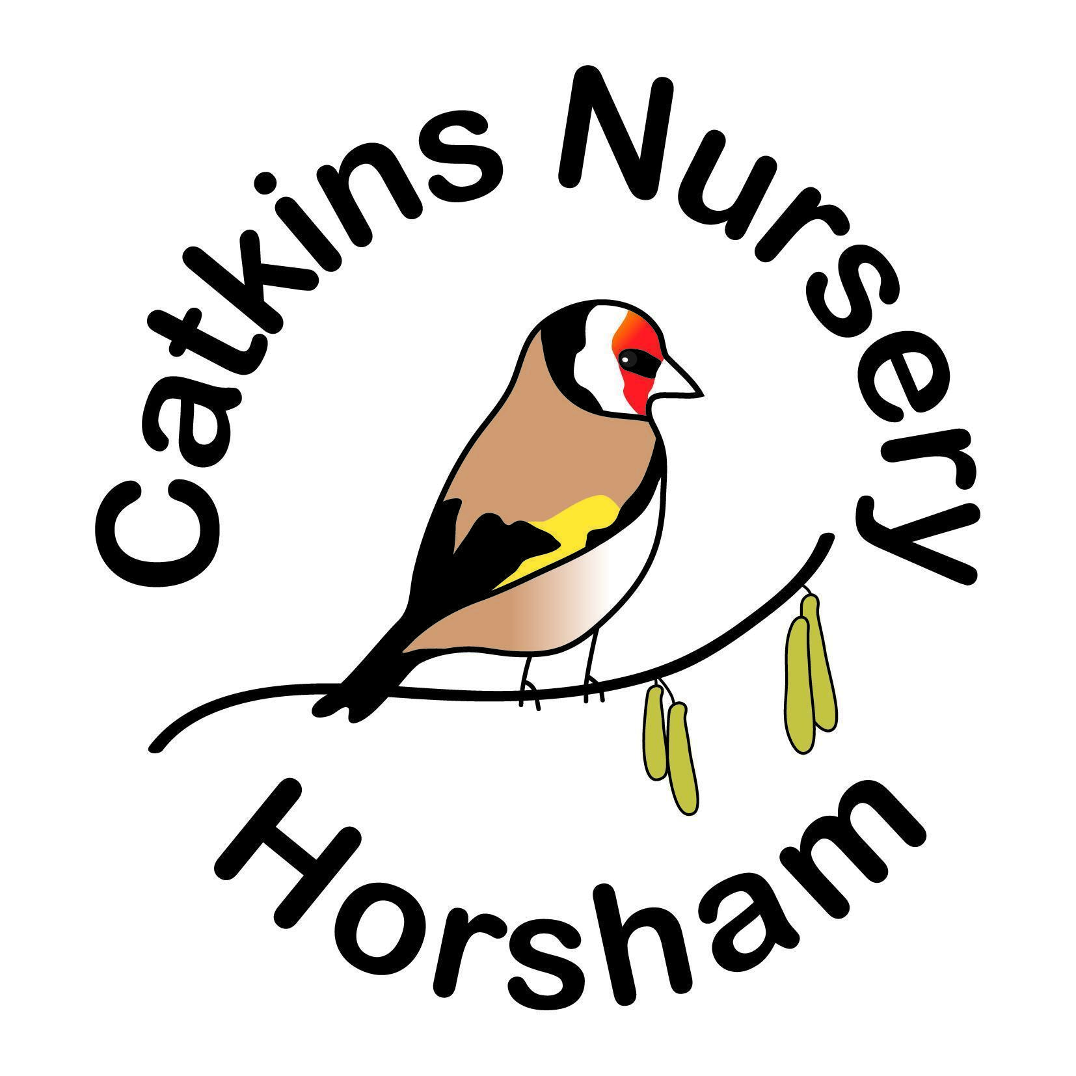

Admissions Policy & Procedure &

The Government Funding (EYFE) Pattern of Delivery.

Children may commence at Catkins Nursery from two years of age. Children start Catkins with a minimum of two x three-hour long sessions a week if they are starting prior to EYFE. There is no minimum attendance enforced for children accessing EYFE, but two sessions a week is suggested as in our many years of experience we have found it helps the children to settle into nursery, they may start at any time subject to places being available.
After viewing the setting, once parents/carers have registered their child and paid the registration fee, (this is not applicable for children taking government funded hours only), the child is entered onto the waiting list. When the child approaches 2 years of age the manager will contact the family to attend the nursery to discuss days and to arrange pre-start visits. The child will attend nursery on, (usually), three dates where staff can meet the child again and give out the administration pack and information and learn a little more about the child and their likes and dislikes and to introduce the staff team once more and allow the child to access activities on offer and get to know the environment.
We suggest that your requirements are discussed with the manager on an individual basis when your child becomes eligible for the government funding (EYFE) if commencing nursery prior to this. We would aim to increase the number of sessions available if required.
Government funding is applied on a 50-week year basis on 'stretched funding' only at Catkins Nursery, this means funding is available for up to 11 hours a week all year around, or up to 22 hours if 30 hours are claimed. With extra 'spare' hours taken equally over the whole year, as a number of hours per term as the funding does not always equate neatly into the 50 weeks that we are open. Once children begin their government funding, an ‘Extra Curricular Activities’ and ‘Food & Snacks’ charge is made per session over the calendar month for children accessing it.
This optional charge is for extras provided over and above the basic EYFS, (curriculum) service and is applied per session your child attends. This is to cover the cost of food, (snacks & teas), and extra-curricular activities which include; special ‘one off’ celebrations, special meals, birthday treats, Eid gift bags, the leaver’s party, lunch, gift and certificates, caterpillar/butterfly experiences, visitors with specific skills or items/animals to show, Music Bus etc! Valentine’s day gifts and experiences, and presents, Mothering Sunday gifts, Father’s Day gifts, Easter egg hunts & cooking, Christmas activities, parties and Father Christmas gifts, Chinese New Year gifts, Shrove Tuesday cooking activity and other cooking activities throughout the year where children eat their cooking at nursery or take it home. The charge is to cover the additional costs of providing these experiences because the government funding does not meet the hourly fees charged at Catkins Nursery to be able to provide these activities without an additional charge. A full list of these activities is also given to the parent in the EYFE Pack supplied by nursery in the term before EYFE commences.
I am required to list all the extra-curricular activities that we undertake by W.S.C.C. so that all parents understand exactly what the extra-curricular charge goes towards. This list however is not exhaustive and as always we find new and exciting things for the children to experience.

Catkins values the need for, & importance of these additional services, & for each child to be treated the same. The payment of these fees enables your child to participate in all of these activities, please see the nursery manager if you wish to consider ‘opting out’ & for up-to-date details of the application of the government funding, for 15 or 30hrs if unsure.
The option of taking the government funding over 38 weeks, term time only is not offered as Catkins is an ‘all year around’ nursery.

Admissions Policy and Procedure Including the application of the EYFE Continued Page 2: -

Three, free pre-start ‘taster sessions’ are usually arranged: -
- Upon the first visit the child & family are welcomed by staff & will attend for an hour's session with the child.
The parent/carer is given the necessary forms to take away to fill in once explained. Medicine, collection, password procedures, and basic routine is explained along with any other queries the parent may have.
The child is able to access the activities out for the day & staff will encourage the child but will be aware that the child may be unsure & may need the parent to take part in activities with them & stay close. No expectations will be made of the child & staff do not insist a child sits for songs or stories at this time. It is not a worry for staff if a child does not sit, it is a lot for a child to experience on their first visit & we will work with the parent & the child’s interests and stage of development, to ensure their visit is a happy one.
- Upon the second visit, the child usually stays for a slightly longer session than before, and all the paperwork must be returned and checked by a senior staff member to ensure it is all complete before the child is left for a short period of time in agreement with the parent.
- On the third visit, the child may be left for the session depending on how previous visits have been. Nursery staff will ensure the child is supported and it is preferable that the child has a good time as they become familiar with a new environment and new people rather than becoming too upset. A judgment will be made on the day to see how the child copes, and in discussion with the parent.
- Should a child become upset or overly distressed at any point, on visits or when they commence nursery, a decision will be made by staff, and the parent may be telephoned so that the parent returns and the child may finish the visit/session happily with the parent present.
- Discussions will take place with the parent and supervisor and key person to decide the best way to help each individual child to settle. Key persons will preferably be allocated on a visit so they can get to know your child.
During any period of ongoing pandemic, all parents will attend as per the guidelines at the time. Updates will be issued as appropriate.

Fees
Prior to the government funding (EYFE), or for non-EYFE 2-year-olds, cash fees are payable. Current fee level can be obtained from the manager and is subject to a review each April/September. Fees are payable for sickness, family annual leave and bank holidays; except for Christmas Day and Boxing Day and the days in between the Christmas and New Year break, and for the one-week nursery closure for a full working week in August, (dates to be confirmed annually). Bank Holidays will not be charged.

There is a charge for food and a charge for extra curricular activities as detailed above. If you would like to discuss this further please speak to the manager.

Fees are payable by BACS and need to be received and cleared by the last working day of the preceding month, please see the manager if you wish to settle your bill by any other method of payment.

We try to be eco-friendly by avoiding paper invoices & envelopes; invoices are usually sent through Tapastry. They are usually sent out around the 25th of the month.

Admissions Policy and Procedure Including the application of the EYFE Continued Page 3: -

The details for electronic payments of the nursery bank account can be found on the invoice itself or in the parent handbook which each family is given on starting nursery.
A ‘BACS’ electronic payment is preferable.

The application forms relating to the government funding (EYFE) will be given to you as an ‘EYFE Pack’ and explained in the term before your child becomes eligible for funding. Should you wish to see these prior to commencing nursery please ask a supervisor.
An actual birth certificate or passport must be brought for the manager to see (we regret just the photocopied document is not acceptable), we countersign the EYFE form to confirm we have seen the original copy.
Forms must be returned before the beginning of the term in which the child is funded so the paperwork is complete and there are no queries with them before the 'final headcount day'. ‘Headcount Day’ is usually the third Thursday of the term and after this no alterations may be made to a funded child’s hours.
Children accessing EYFE are able to do so on 'stretched funding’ over 50 weeks giving up to approximately 11 hours per week if taking 15 hours, or up to approximately 22 hours a week if taking 30 hours of EYFE. There is no minimum number of hours required for EYFE children. As the EYFE does not fit 'neatly' into the 50 weeks we are open & it may only be claimed to the half-hour, there may be some hours unused. These 'spare' hours can be used up in discussion with the manager & evened out over the year.
Term time only funding is not offered by Catkins Nursery due to the need to run as an all year around setting. Hours for EYFE are allocated and are subject to availability as some sessions are offered as EYFE only sessions. There is a limit to the number of 2, 3 and 4yr olds accessing EYFE attending the setting, depending on places available.

If your child misses EYFE sessions due to illness, holidays or any planned or unplanned absence, these hours will not be available at a later date. If Catkins Nursery is unexpectedly closed during your child’s regularly scheduled EYFE sessions, due to illness or other unforeseen reason, we will offer these hours at an alternative time subject to availability and where reasonable.
The West Sussex Family Information Service may be contacted if required for further information on the 'Free Entitlement’ on 01243 777807.

Session Allocation and Pattern of EYFE Delivery
We will do our best to accommodate each family's needs with the application of the EYFE and are very flexible in its' application compared to many settings.
Places and sessions specifically allocated for funded sessions, (EYFE) must be filled first before other sessions are taken up by funded children. These funded sessions may start at 9am or finish at 6pm. The number of EYFE places throughout the week may vary according to age of children and staffing levels. This must be discussed with the manager for up-to-date occupation of places. The number of two-year-old EYFE spaces may be capped, depending on demand for places within the nursery. This may vary depending on the term and the number of 2yr olds attending nursery and is at the absolute discretion of the manager.
There is a charge for lunch/tea, as a high quality, hot nursery lunch/nutritious tea and pudding is provided. This is a lovely social time and supports children to develop real life skills, try different foods and engage with each other.
If paying for food is not something you wish to do then you can opt out and provide a healthy packed lunch for your child, the packed lunch will be checked each day by a supervisor to ensure there are no foods containing nuts and ensure the lunch is healthy, no sweets, crisps, chocolate bars, juice or fizzy drinks. A healthy lunch box handout is available should you require guidance.
Lunch boxes must have cold packs inside them as we do not have space to store them in our fridges.

Admissions Policy and Procedure Including the application of the EYFE Continued Page 4: -

Occasionally sessions may need to be altered for EYFE only hours taken, in order to fit in 'cash fee' children. The place is still available to the EYFE child, and it is not necessary to reserve a place each term, however the days and session times may be altered with up to 4 week’s notice if nursery is reaching capacity and a space needs to be made for a cash fee child on a particular morning or afternoon in order to even out attendance numbers or make a space available. This will be discussed with the parent if the need arises and mutually agreed. Whilst every effort will be made to give a preferred alternative day, any such session change is ultimately 'Catkins Nursery' decision as priority is given to full-time or cash fee children.

The application of the Early Years Funded Entitlement over 'self stretched weeks' means that over the year there are 20 hours of funding still to take for a child claiming maximum hours of 11 per week as 'self stretched' funding. This may vary according to the number of EYFE hours claimed or if a child is taking 30 hours of EYFE.
Catkins can give these unused 'spare' hours to parents as extra sessions. This means that each child attending 11 hours a week has 20 hours divided over the three terms to use for extra hours attendance. Catkins Nursery allocates the hours over the three terms in the year so that none are lost and unused. This means that the 20 'spare' hours are offered over the year claimed if the full EYFE allowance is used. A similar pattern is offered for those children taking up to 30 hours EYFE.

Staff children may have a ‘tailored pattern of delivery’ according to staff hours worked, this will be determined on an individual staff basis and may be on a rota, but with EYFE hours noted as used on the monthly invoice and used over the term.

These ‘spare’ sessions may be used in addition to the weekly sessions your child attends & not as part 'payment' to cash fees. Therefore, should you require an extra, or extended session you may request it. The sessions may be taken as 9am – 12noon, or 2-5/6pm sessions.
Extra hours may only be booked in person with the manager. If you wish to book an extra session, parents must complete a message slip at Catkins Nursery & the manager will confirm if the space is available or please see the manager in person.

Children will be allocated places at Catkins Nursery under the following criteria: -
- Priority will be given to children who take a full-time space & siblings of children previously/currently attending Catkins Nursery full time will have priority.
2. A child taking more hours per week will have priority over a child attending less,
for e.g. a child taking two sessions a week on EYFE as 6 hours, will have lower
priority than a child attending over two full days per week.
3. Where children of approximately the same age, are on the waiting list with no
past/present siblings or relatives having attended nursery, and equal hours
taken, then they will usually be offered a place according to the date they were
taken onto the waiting list.
4. The owner’s decision is final regarding the final allocation of places and
Individual circumstances may mean allocation is given with this taken into
account. Any personal details will not be discussed with any other family with a
child on the waiting list, in accordance with the confidentiality policy.

Should you choose to withdraw your child, Catkins Childcare requires 4 weeks written notice for EYFE sessions, inclusive of holidays and periods of closure. If you move to another provider within West Sussex after the notice period, your new provider can contact us to request transfer of any remaining funding we have claimed on your child’s behalf.
We aim to make our setting accessible to children & families from all sections of the local community. We welcome all carers; Fathers, Mothers, Grandparents and other relations, friends and Childminders. We do not, and shall not discriminate on the basis of race, colour, religion (creed), gender, gender expression, age, national origin (ancestry), disability, marital status, sexual orientation, or military status, in any of its activities or operations. We aim for our information to be widely available in a format that is accessible to all. Please ask if you require information in a different format or language.

************************
Updated June 2026. To be updated on or before June 2027. Catkins Child Care Sussex Ltd

